Design for using Intent App:

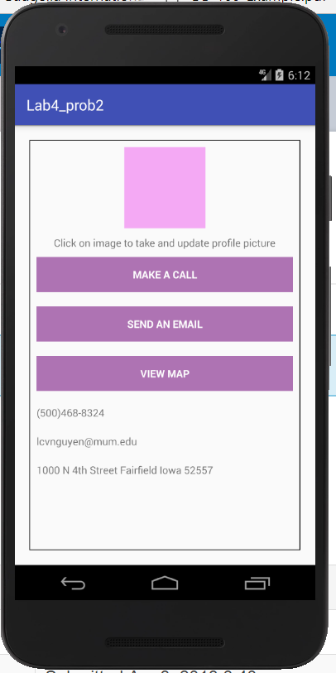

Application will help user can change their profile image by using camera of android device

User can make a call to number that is in layout screen

User can send an email to email address in layout screen

User can view the map with location in layout screen